MANEKI – NEKO
- It is a figurine of a cat with a short tail depicted in a sitting position with a raised paw in the gesture of summoning.
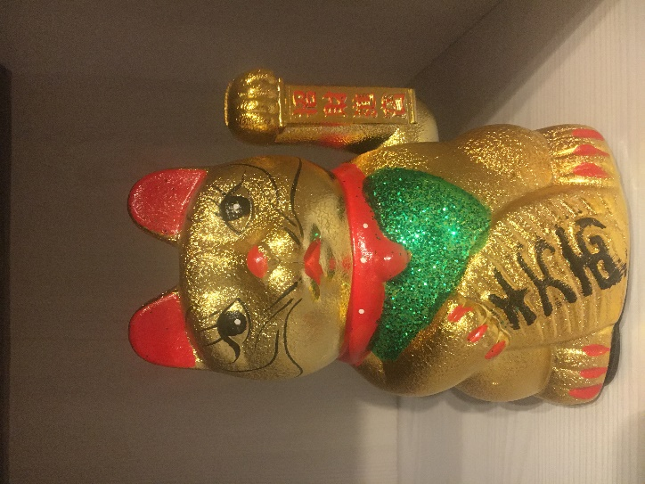

CANDIES
- The most popular candies in China are dried fruits. Children’s delicacy are crow’s feet.
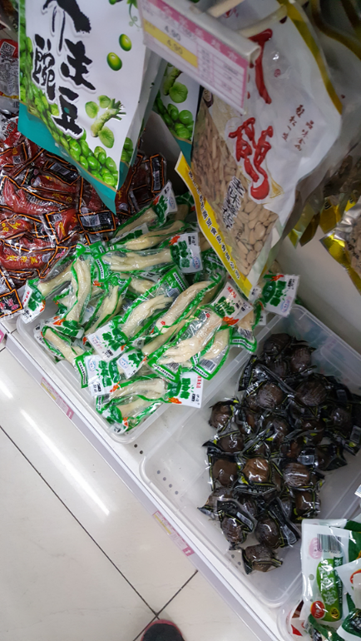
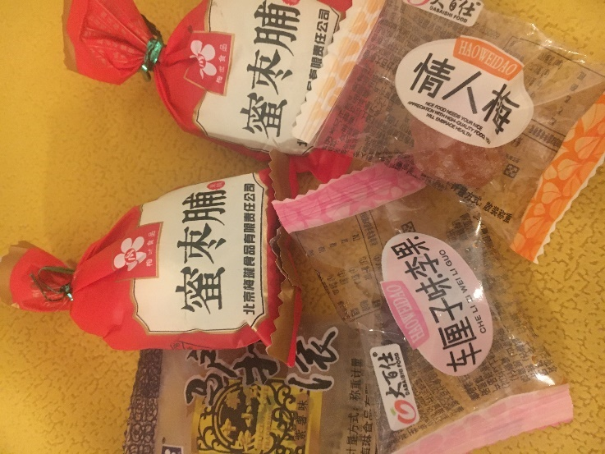

CHINESE UMBRELLA
- It is one of geisha’s symbols. Geisha is a woman who wears special outfit and makeup for some celebrations.

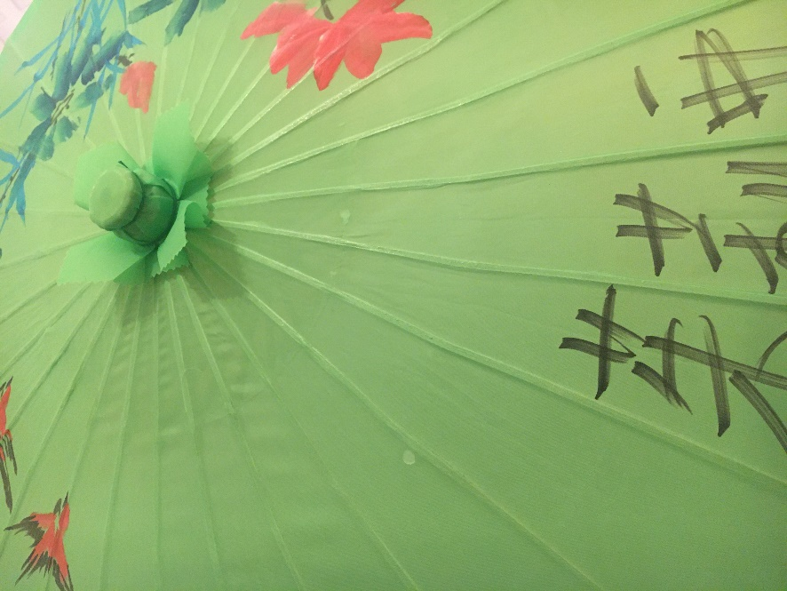

CHINESE HAT
- protects peoples’ heads from the sun while they are collecting rice from fields.
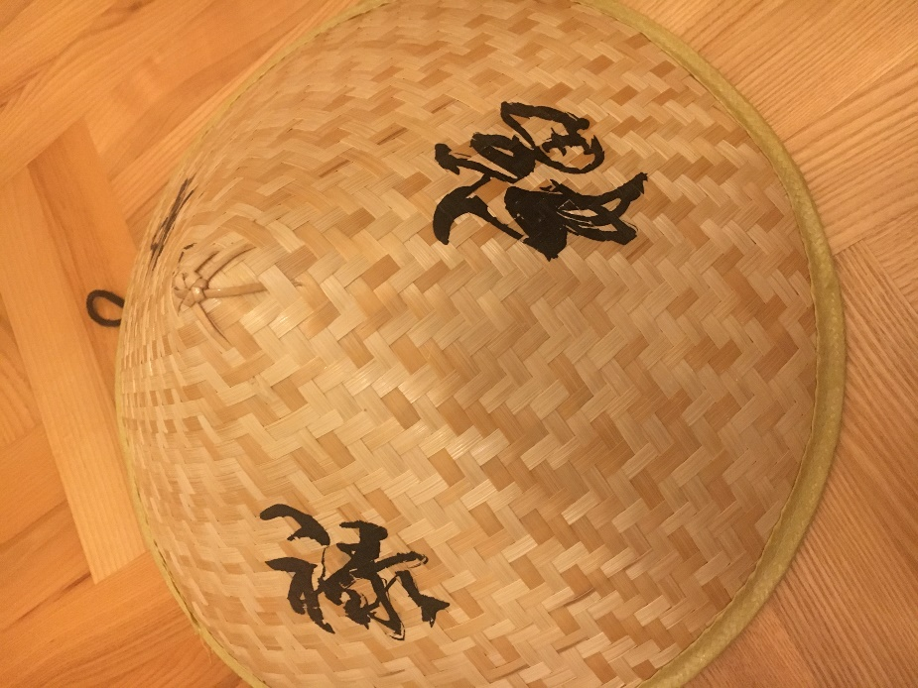

CHINESE CUTOUT
- traditional Chinese cutout made on the occasion of the New Year.
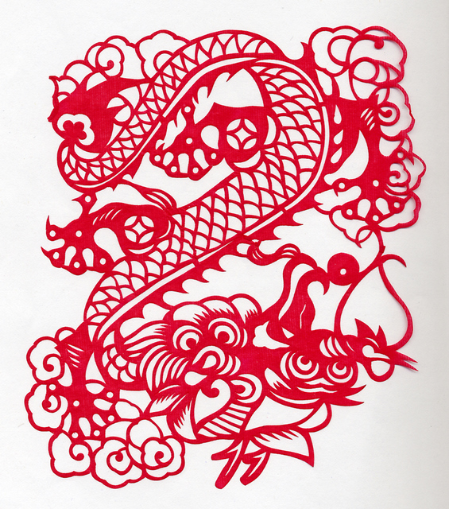

CHINA
- You can meet a hairdresser on a street.
