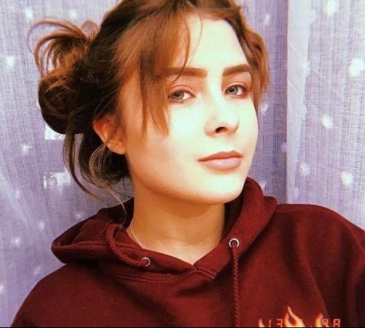
Hi, my name is Ania and I'm 13 years old. I attend primary school no 21,bilingual class 7B.
My favorite subject is Physical education, History and Polish
(I don't like grammar ☹).
I played sports from an early age. First, I attended ballet, then karate. I rode a horse and swam. Recently, I have trained sports acrobatics.
I currently want to play volleyball.
I live with my parents and my older sister. I have a long-haired German Shepherd dog - Tara and a Maine Coon Chanel cat.
I love my family.
In my free time I like meeting my friends. I'm open to new friends. I love watching movies with my mother and I like shopping with her. I talk to my dad about the history of our country.
I love to sleep and rest. I do not like cleaning. Maybe I'm a bit little lazy ☺?
I am sensitive and empathic, I try to understand and explain the behavior of others. I like talking and helping others with solve their problems and troubles.
In the future I would like to become an HR Manager or Headhunter in an international company. That's why I'm learning English to achieve my goal.

