MY DAILY MENU
By Nikola:

Monday – breakfast

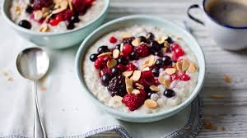
For breakfast I have porridge with fruits. I like it because its healthy and tasty. Sometimes I also eat some sandwiches or pancakes for breakfast. I also like to drink some tea with it.

Tuesday – lunch
For lunch I have yogurt with fruits. It’s easy to prepare, very healthy and it tastes delicious. When I have time, I sometimes prepare some sandwiches with cheese and tomato.
For lunch I have yoghourt with fruits. It’s easy to prepare, very healthy as well. I sometimes prepare some sandwiches with cheese and tomato.

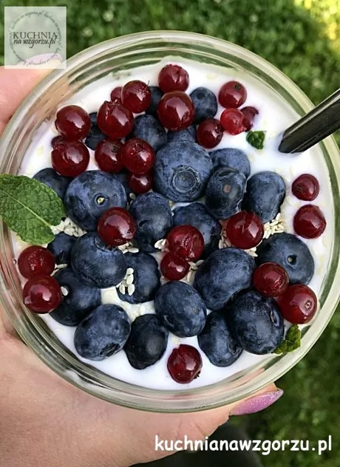
Wednesday – Dinner
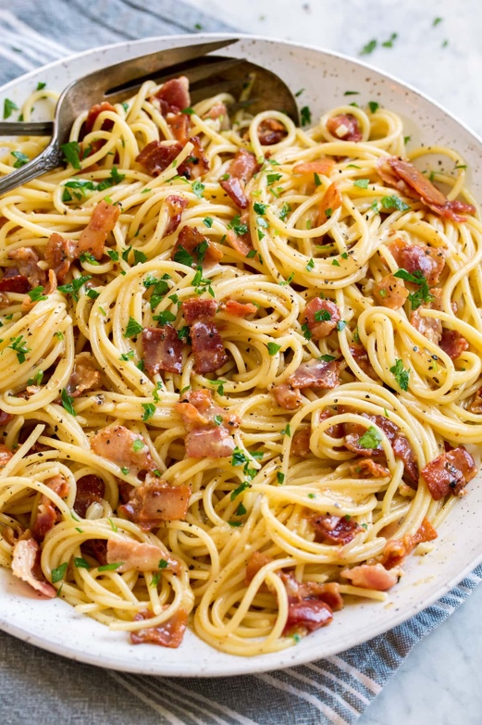
For dinner I have Pasta Carbonara. It’s very delicious dish. Usually I eat different kind of pasta and soups like chicken soup or tomato soup.
Thursday – Dessert
I don't usually eat desserts, but if I do, it's usually a piece of cake that I baked with my mom. It’s healthier than cake from bakery because we know the ingredients that are in this cake and we can modificate recipe to our own ideas.
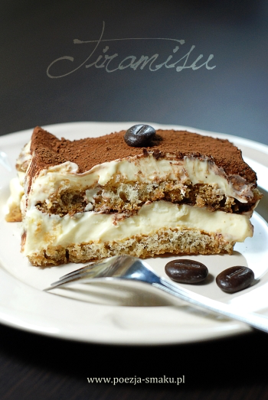
Friday – Supper
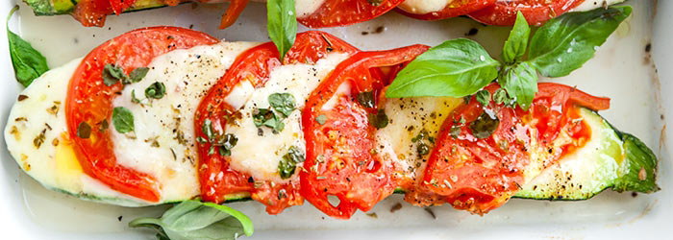
For supper I have baked zuckin with mozzarella tomatoes and basil. It’s healthy and in my opinion delicious.

