MY DAILY MENU

BREAKFAST.
Today for breakfast I made my speciality and that is egg and bread with spices and fried mushroom with ham.
How to make this? Easy - peasy
Firstly, heat the frying pan, cut mushrooms with ham and put on the frying pan.
Next, put bread and egg on the frying pan.
At the end, add some spices . And Voilà !!!
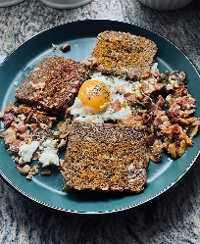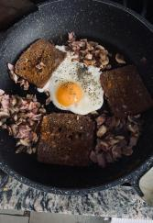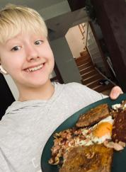

LUNCH.
Obviously for lunch I make smoothie. I just mix strawberry and banana in the blender.
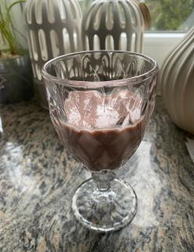

DINNER.
For dinner I eat perfect puree, vegetables and meat with pepper sauce.
I don’t know exactly how it is made, because my mum did this dish for me.
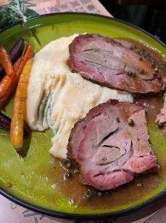

SUPPER.
For supper I make usual sandwiches: with eggs or ham and cheese.
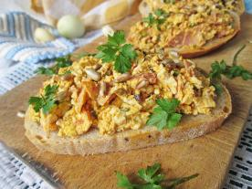
Sometimes I eat some sweets like healthy cookies or ice cream. <3

